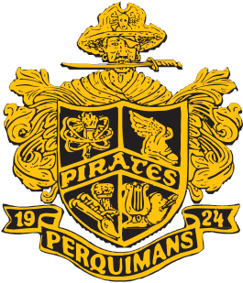

Mickey Drew
Principal

Teressa Blanchard
Assistant Principal

Michael Dufrene
Assistant Principal

PERQUIMANS COUNTY HIGH SCHOOL
Post Office Box 398
305 Edenton Rd St
Hertford, North Carolina 27944

Phone: (252)-426-5778 www.pqschools.org Fax: (252)426-7614

2022 – 2023 School Supply List

- 2” 3-Ring Binder
- Dividers (4)
- 4 Highlighters
- 4 Composition Notebook or Spiral Composition Notebook
- 2 Packages of Paper, college-ruled (loose leaf)
- 2 Packages of Index Cards, 3x5, Ruled
- 4 Folders with pockets
- Glue Sticks
- #2 Pencils
- Pens (Blue or Black)
- Ear buds or Headphones
- Band students will need 1” 3-Ring Binder with 20 Sheet Protectors

Note: Due to the nature of the course, some teachers may have content
specific requirements that will be shared during the first class meeting.

